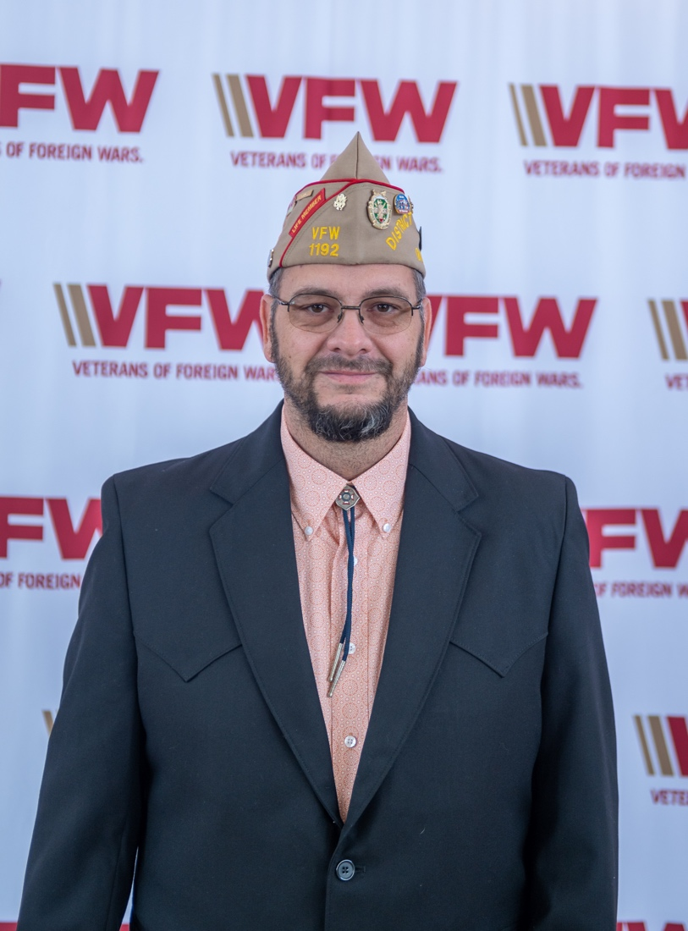

Responsibilities of a Chaplain
BEING A CHAPLAIN
You were elected to the office of Post/District Chaplain.
You have an important responsibility to your Post/District.
Whether you have been selected for your religious training or past VFW experiences, you are expected to be the spiritual advisor to your organization and its members.
You are not expected to know everything but are expected to search for the answer and get back to the individual. Do not be afraid to ask questions when necessary. There are many ministers of faiths/denominations and chaplains that are willing to assist you. As you meet them, create a contact list and offer veteran/VFW/chaplain assistance when they need it. All will benefit from the experience.
**********************************************************

PURPOSE OF CHAPLAINS
The office of Chaplain is not just to provide a "religious” officer to the organization to offer prayers at meetings. He or she has higher purposes:
1- To help persons grow in their relationship with God.
2- To help persons grow in their relationships to one another and become a true comrade/sister to one another.
3- To serve as a reminder of the transcendent in life.
4- To develop an environment with which comrades and sisters are encouraged in their personal and collective moral and spiritual growth.
5- To remind all Americans that God is the source of all rights and privileges.
We must be reminded that the Veterans of Foreign Wars is comprehensive in nature, embracing all religions and faith groups within its ranks. The Chaplaincy, being non-sectarian must minister to the spiritual needs of all, without regard to either church/synagogue/mosque affiliation or non-affiliation. Chaplains will need to provide ministry to people wherever there is a need.

QUALIFICATIONS OF CHAPLAINS
The qualifications for the Veterans of Foreign Wars Chaplain are not academic or ecclesiastical. A VFW Chaplain candidate is not required to be a "professional” clergy person. (Most Post/Auxiliary Chaplains are not.) The qualifications are simple yet important:
1- A willingness to serve the office.
2- A sense of spiritual maturity.
3- Committed to providing a Chaplain’s ministry.
4- A caring person.
5- A desire to help people.
6- The ability to keep things confidential.(Extremely important.)
7- Willing to be neutral and objective when settling disputes.
8- Voice projection and the ability to read well in public.
9- Should have a positive attitude toward him/herself.
10- Chaplains should be proud of their office and determined to do a good job.

Duties and Responsibilities of the Chaplain
1. In a non-sectarian manner, you should be prepared to listen to your fellow comrades/sisters and provide aid and spiritual comfort in times of stress, sickness, or bereavement.
2. Work with your Service Officer to aid members and their families in time of need.
3. Your Post Commander or Officers may come to you in confidence. Remember the privileged communication you are having is for your ears only. Uphold the high ideals of the organization in any advice you offer. Remember it is a privilege – respect it.
4. You should be prepared to offer the ritual prayers at each meeting of the Post. You will also be called upon to offer appropriate prayers at the initiation of new members; installation of officers; the dedication of a building, monument or colors; or at the memorial service of a comrade.
Note: All such services are commemorated by use of the VFW or Auxiliary ritual.
5. Being a member of the Post’s Memorial Team will provide an opportunity for contact with the grieving family and thus provides a caring ministry to them. The Memorial Team is an important part of the honors offered to a veteran.
6. Use the persuasion of your office to promote harmony and unity in the Post/District/State.

Additional Duties & Responsibilities
- A person of moral and intellectual qualities
- A member of the Executive Committee
- Your Post’s official representative at Religious and Civic affairs in the great community
- A pastoral caregiver
- Conduct and/or participate in Memorial, and Funeral Services when called upon
- Send cards to sick and bereaved
- Visit sick, bereaved and hospitalized
- Participation in Parades, 9/11 Memorial Services, Veterans Day Programs/Services, and POW/MIA Services
- Presenting Memorial Bibles to deceased members’ Family
- Generate respect for the office of Chaplain

VFW Chaplain Statement of Ethics and Guiding Principles
1. Chaplains will demonstrate utmost personal and professional integrity: truthfulness, honesty, and compassion to those who they minister to.
2. Chaplains will provide an objective, appropriate, holistic support and a comforting presence.
3. Chaplains will not proselytize. Those who are cared for will be provided freedom from unwanted gifts of religious literature or symbols, evangelistic and sermonizing speech, or forced acceptance of specific moral values and traditions.
4. Chaplains will demonstrate sensitivity to all faith traditions and provide appropriate and sensitive spiritual care to all persons in need, irrespective of their religious or nonreligious identity.
5. Chaplains will not discriminate, with regards to their care, based on sex, age, race, ethnicity, religion, sexual orientation, disabilities, socioeconomic status, or any other factors that would hamper a person’s ability to receive spiritual care.
6. Chaplains will, whenever possible, attempt to locate a spiritual leader within the faith tradition of an affected person, if needed.
7. Out of respect for those who are served, Chaplains will maintain confidentiality.
8. Chaplains recognize their personal and professional limits, know their boundaries and make referrals to professionals with appropriate expertise.
9. Chaplains will do no harm.

Key Resources
These three sources are most likely the three most important resources a chaplain in the VFW needs in order to accomplish their general duties.
The complete resources are listed here for easy downloading. They may be printed by you and will fit nicely in a binder for easy access. I suggest you have a printed copy always available along with anything else printed that you might need. Finding things on smart phones and tablets can be challenging in a hurry and if the internet is not available or the battery change runs out, you may not be able to use them at all. I do have all of this saved in files on my smart phone and Kindle, but I also have a hard copy in my car.
So far as price for printing, there are some less expensive options if your post is unable to print them for you. Many libraries offer so many pages per month free with your library card. I know that the St. Louis Public Library offers 200 pages free per month and heard that Springfield, Missouri offers copies for five cents each. Check around. Often talking to the manager about your job and asking for a reduction in price also will get you a break on the cost of printing.

Chaplains Resource Manual

https://movfw.org/uploads/Documents/chaplain/Chaplains-Resource-Manual1.pdf

Resources For Chaplains

https://movfw.org/uploads/Documents/Forms-and-Documents/ResourcesForChaplains.pdf

VFW Meeting Prayers

https://movfw.org/uploads/Documents/chaplain/VFW-Prayers-for-Comrades.pdf

Bible Ordering

https://movfw.org/uploads/Documents/Forms-and-Documents/BibleOrdering.pdf

2023 Chaplain’s Handbook

https://movfw.org/uploads/Documents/Forms-and-Documents/2023RevisedChaplainsHandbook.pdf

References
ADDITIONAL REFERENCES FOR CHAPLAINS
The references on this page are extra ones added to further research you may be doing. Although they maybe valuable from time to time, they are not necessary for you to print just to have a copy unless your specific duties call for you to use them.
Some of the references listed here may have been listed elsewhere on this site as well.
If you have other references you think might be helpful to other chaplains, please email them to me at
vfwokchaplain@outlook.com

Religious Support at Funerals
https://movfw.org/uploads/Documents/chaplain/Religious-Support-at-Funerals-ATP-1-05.02.pdf
Religious Support in Joint Operations
https://movfw.org/uploads/Documents/chaplain/Joint-Publication-105.pdf
Religious Support
https://movfw.org/uploads/Documents/chaplain/FM-105.pdf
The New Ministers Manual
https://movfw.org/uploads/Documents/chaplain/The-New-Ministers-Manual.pdf
Benedictions and Closing Prayers
https://movfw.org/uploads/Documents/chaplain/2010ChaplainsHandbook_Benedictions.pdf
Supporting Veterans in Recover; Strategies for Family, Friends and Communities
http://whitelightbh.com/resources/supporting-veterans-in-recovery/

Training
TRAINING IS IMPORTANT!
Most of us come to chaplaincy without formal ministry training and are at a loss of how to accomplish the many things a Chaplain has to do in order to take good care of the members in our post.
Listed on this page are short training items to assist you in your duties as a Chaplain in the Veterans of Foreign Wars. The short training items are not in a particular order, but will be as the items are developed.
We are looking for feed back from our Chaplains as to topics you want to see here. Please email me at: vfwokchaplain@outlook.com
Chaplain – Be a Mentor
https://movfw.org/uploads/Documents/chaplain/Chaplain-Be-a-Mentor.pdf
Dealing With Suicide as a Chaplain
https://movfw.org/uploads/Documents/chaplain/Dealing-With-Suicide-as-a-Chaplain.pdf
Speaking in Public
https://movfw.org/uploads/Documents/chaplain/Speaking-in-Public.pdf

Credibility of Chaplains and Leadership
https://movfw.org/uploads/Documents/chaplain/Credibility-of-Chaplains-and-Leadership.pdf

The Reading of the Prayers
https://movfw.org/uploads/Documents/chaplain/The-Reading-of-the-Prayers.pdf

Articles
The articles come from a variety of sources. I tried to post the ones I felt would be of most interest to a VFW Chaplain. Should you come across something of interest that you do not see here, please send it to me at vfwokchaplain@outlook.com
Hopefully you will find these enjoyable and informative!
VFW Chaplains Organizational Structure
https://movfw.org/uploads/Documents/chaplain/VFW-Chaplains-Organizational-Structure.pdf
February 3 Four Chaplains Day
https://movfw.org/uploads/Documents/chaplain/February-3-Four-Chaplains-Day.pdf
National Four Chaplains Day – Feb 3
https://movfw.org/uploads/Documents/chaplain/National-Four-Chaplains-Day-Feb-3.pdf
Who’s Gonna Fill Our Shoes
https://movfw.org/uploads/Documents/chaplain/Whos-Gonna-Fill-Our-Shoes.pdf

Oklahoma VFW Chaplain's Reporting Program

This program is for Oklahoma’s VFW Chaplains to report within the state. Other states are welcome to copy and use the form but must use it within their own state reporting system.

Jason Burns
State Chaplain Dept of Oklahoma
vfwokchaplain@outlook.com

